**Coding Conventions**

**Bracing:**

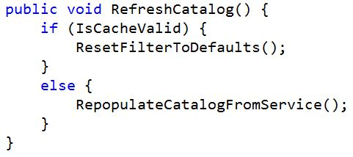

**Naming Prefixes:**

These letters precede the the chosen name for variables, functions, and classes. Variables and parameters begin with lowercase letter while functions and classes begin with uppercase letter.

* **‘G’** -Global variable
* **‘M’** - Member variable
* **‘P’** - Pointer variable
* **‘V’** - Virtual function
* **‘I’** - Interface class

**Naming Capitalization:**

* Make sure that our variables always start with a lower case
* Any multi word variable, classes,function and methods are used typed in camel casing for example:
* int iHaveWon;
* Any macros or convention will be typed out using underscores to separate words and typed out in all caps

**Documentation:**

* **start with a line of asterisks and end your comment line with another bar of asterisks**

/***************************

* Function Name

* Description

* Parameters

* Return

***************************/

/***************************

* File Name

* Authors and Copyright

* Date Created

* Last Update

* Version

* Description

***************************/

**Minimum System Requirements**

* **OS:** Windows 7 32-bit
* **CPU:** Intel Core i3 or better
* **Memory:** 1024 MB RAM
* **Video Card:** GeForce GTX 560 or any card compatible with DirectX 12
* **Sound Card:** Any card compatible with DirectX 12

**Project Directory**

* **'Docs'** folder contains GDD/TDD and other documentation of plans regarding the engine.
* **'Assets'** folder may contain 2D art, 3D models, sfx, and bgm files
* **'Source'** folder only holds scripts (eg. .cpp and .h). Do NOT put .dll or .exe files.
* **'Test'** folder are for test scripts and logs
* **'Blue Rapsol Engine'** is for the release build. This is where executables and DLLs go. Data files go in sub folder 'Data'